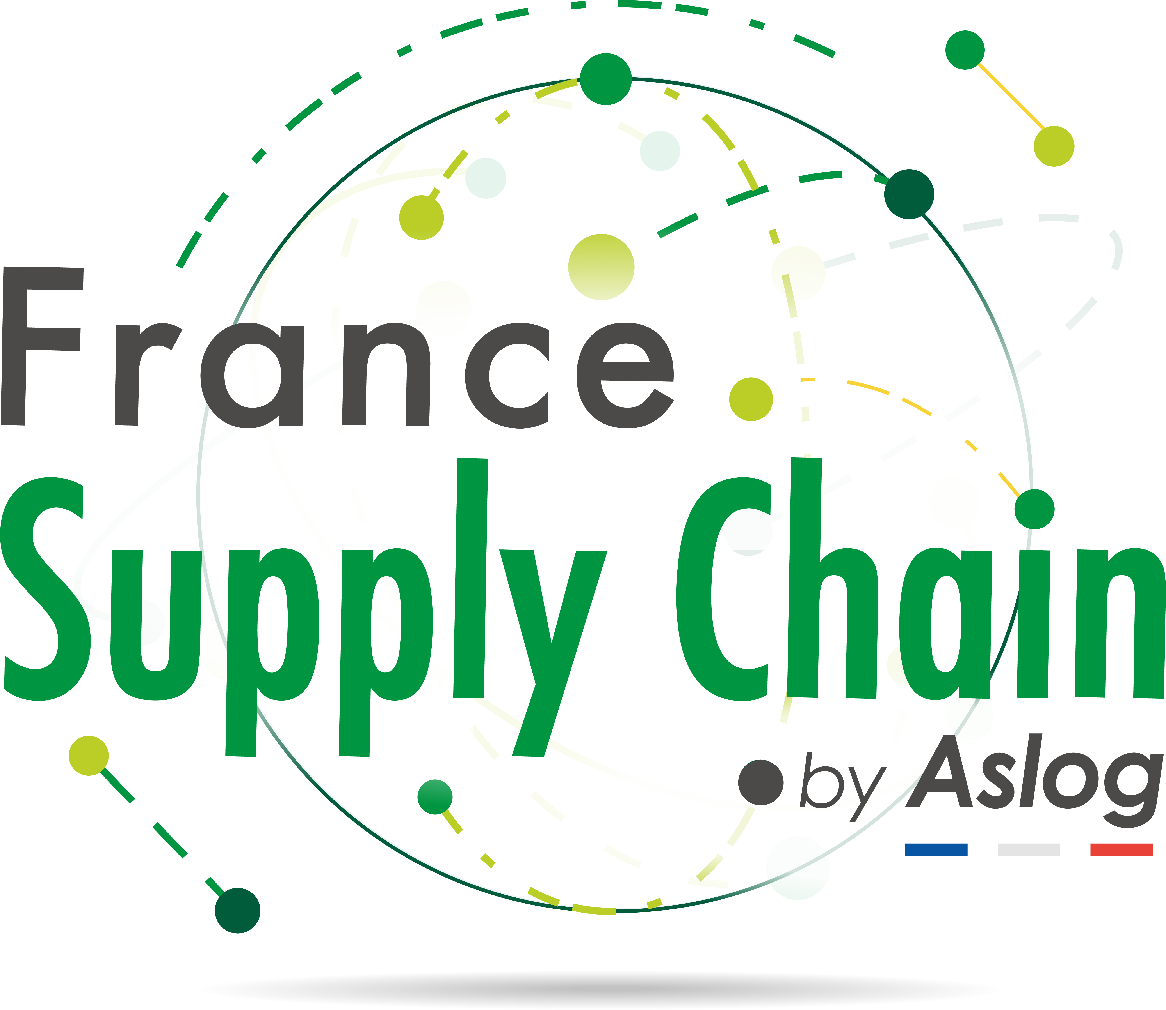



**France Supply Chain Award  
for the best article on Sustainable Supply Chain**

**2026 edition**

**Application rules for papers published between**

**January 1rst, 2024 and December 31rst, 2025**

**Article 1**

As part of the **Supply Chain 4 Good Fund, the France Supply Chain association** has joined forces with **the International Association for Research in Logistics and Supply Chain Management**(AIRL-SCM) to reward a scientific publication that makes a significant contribution to the field of **Sustainable Supply Chain**.

Sustainable Supply Chain can be defined as "*the management of flows (information, physical and financial) and relationships with all supply chain stakeholders, taking into account environmental and social objectives*" (according to Seuring and Müller, 2008).

**Article 2**

The aim of this call for papers is to reward academic work carried out in the specific fields of **logistics management and *supply chain management***, in line with the **manifesto *for a more sustainable supply chain*** drawn up by the France Supply Chain association [(https://www.francesupplychain.org/manifeste/](https://www.francesupplychain.org/manifeste/)).

This operation makes it possible to draw the attention of the entire community in these fields to **research work of excellent or exceptional level**, in terms of both form and content, carried out by researchers who have recently published their research.

**Article 3**

The **2026 edition of** the Prize is open to teacher-researchers who have published **an article** in the field of Sustainable Supply Chain Management between **January 1rst, 2024 and December 31rst, 2025**. The article can be written in French or in English.

**Article 4**

The award for this article will take the form of a prize of **2,000€ awarded by France Supply Chain to the winner(s)** at a ceremony during the next AIRL-SCM Conference to be held from May 27 to 29, 2026 in Saint Malo, France.

**Article 5**

To distinguish the best articles, the **jury**, made up of scientific members of AIRL-SCM and practitioners members of France Supply Chain, will evaluate the articles according to the following criteria:

* Importance of the subject for France Supply Chain members (e.g. link with the labs, link with the *manifesto for a more sustainable supply chain*).
* Nature of research contributions: academic, methodological, managerial.
* Potential impact of results (e.g. potential to influence decisions in companies or public bodies).
* Innovative content.
* Practical usefulness.

**Article 6**

The competition rules, timetable and application form (**see Appendix 1**) are available on the France Supply Chain and AIRL-SCM websites at the following addresses:

**https://www.francesupplychain.org**

[**https://www.airl-scm.com**](https://www.airl-scm.com)

**Article 7**

Applications for the “**France Supply Chain Award for the best article on Sustainable Supply Chain – 2026 edition**" consist of a file, to be submitted in **electronic format only**, including all the following documents:

1. **application form** (see appendix 1),
2. a short ***curriculum vitae*** for each author (1 page maximum), including a list of recent publications,
3. **the article submitted** for the prize, giving full publication references

**Article 8**

**Submission of files:** complete files, in a single pdf file, including all the documents listed in Article 7, should be sent to the following e-mail address:

**info@supplychain4good.org**

* Subject of e-mail: **"*Application for the France Supply Chain prize for the best article in Sustainable Supply Chain*".**
* Application **deadline**: **Monday March 2, 2026.**



|  |  |
| --- | --- |
| https://lh5.googleusercontent.com/0aIWtEDj3v5FjiNDvJ6qEAV-rSgtQ0CCWFHRfEKJvM0auocpOyN_C2C7SwIX0AprH-e5_dD7=w16383 | **AIRL-SCM**  International Association for Research in Logistics and *Supply Chain Management* |
|  | | |

**Appendix 1. Candidature File - Edition 2026**

**France Supply Chain Prize for the best article in Sustainable Supply Chain**

**IDENTITY (of corresponding author)**

Last name: First name:

Permanent address :

Tel: E-mail

**REPORTING STRUCTURE**

University/School:

Laboratory:

**ITEM**

Title:

Publication medium:

Publication date:

Reference for citation:

DOI:

***Name : Date : Signature :***